**Title: Stand dieback and collapse in a temperate forest and its impact on forest structure and biodiversity**

Authors: Philip Martin1, Adrian C. Newton1, Paul Evans1, Elena Cantarello1, Edward Mountford2.

Journal: Forest Ecology and Management

1 Centre for Conservation Ecology and Environmental Sciences, Faculty of Science and Technology, Bournemouth University, Poole, BH12 5BB, UK.

2Joint Nature Conservancy Committee, Monkstone House, City Road, Peterborough, PE1 1JY.

**Abstract**

Concern is increasing about large-scale dieback that is occurring in many forest ecosystems, as a result of novel pressures such as climate change and its interactive effects on drought and the spread of pests and diseases. However, understanding of the processes of forest dieback and its potential impacts is limited, owing to the lack of long-term monitoring data for forest stands in which dieback has occurred. Here we present monitoring data collected for 50 years along two transects in a temperate forest ecosystem, in which the canopy dominant beech (*Fagus sylvatica* L.) has demonstrated significant dieback. Results highlighted that a decline in both basal area (BA) and stem density in individual subplots frequently displayed non-linear trajectories, although in the case of BA, the overall pattern of decline was best described by a linear model. Curvilinear responses to BA loss were observed in tree community change; in species richness of the ground flora; and in the percentage cover of grass, providing evidence of thresholds associated with stand dieback. Evidence also suggested that the ability of BA to recover following decline demonstrated a threshold response; where BA declined by more than 25%, it tended not to recover. Critical values of BA for a change in ground flora species richness and grass cover were around 40% decline from initial values. These thresholds are considered in relation to the concept of regime shifts in forest ecosystems, and the potential implications for forest management and conservation are explored. While managers might consider accepting forest dieback as part of an adaptive response of the system to novel environmental conditions, this would likely be associated with significant biodiversity loss.

**Introduction**

In recent years, many forest ecosystems have become the focus of increasing concern owing to the increasing impacts of multiple forms of disturbance, many of which are anthropogenic in origin (Allen et al., 2010; Huntingford et al., 2008). Examples include large-scale forest dieback caused by drought and heat stress, which has been documented recently from all wooded continents, and has been attributed to the effects of climate change (Allen et al., 2010). For example, in the western USA tree mortality rates have increased over the past 50 years, apparently due to regional warming and resulting increases in water deficits (van Mantgem et al., 2009) leading to alteration of forest community composition (Mcintyre et al., 2014). Recent large-scale pest outbreaks may similarly have been influenced by changing climatic conditions. For example in western North American forests, bark beetles (Curculionidae, Scolytinae) have long been major disturbance agents causing 80- 90% mortality among larger trees over scales of millions of hectares (Raffa et al., 2008). However, the magnitude of bark beetle outbreaks has increased substantially in recent years, and epidemics have extended into new areas (Raffa et al., 2008). Similarly, the recent mountain pine beetle outbreak in Canada was the most widespread and severe epidemic ever recorded (Kurz et al., 2008). Drought may also interact with pest attack to cause large-scale tree mortality, as in the recent case of *Pinus edulis* in southwestern USA (Breshears et al., 2005). Major diseases have also recently caused extensive tree mortality, including pine wilt in Asia, Dutch elm disease in Europe and North America, ash dieback in Europe and *Phytophthora* spp. in Australia (Boyd et al., 2013).

Despite such trends, the ecological implications of dieback or collapse of forest ecosystems are poorly understood. A recent IPCC assessment noted that increased tree mortality and associated forest dieback is projected to occur in many regions over the 21st century, and that this is likely to pose risks for carbon storage, biodiversity, wood production, amenity and economic activity (Scholes et al., 2014). However, the magnitude of such risks has not been evaluated in detail (Bellassen and Luyssaert, 2014; Boyd et al., 2013). The impacts of dieback will depend critically on the ability of forest ecosystems to recover from disturbance. Of particular concern are rapid transitions or “regime shifts”, which have been documented in a number of different ecosystem types following major disturbance events (Scheffer and Carpenter, 2003; Scheffer et al., 2001, 2012).

Such regime shifts are thought to occur when the controlling variables in a system (including feedbacks) result in a different set of system structures and dynamics (Walker et al. 2004). A number of studies have provided evidence of regime shifts that have occured in forest ecosystems, such as the impact of spruce budworm on boreal forests in North America (Holling, 1978) and transitions from forest to savannah as a result of changes in fire regimes (Hirota et al., 2011; Staver et al., 2011). Once a regime shift has occurred due to the fact that an ecological threshold has been crossed, recovery to the original ecosystem state may be difficult or even impossible (Petraitis, 2013). While the underlying theory of regime shifts or abrupt transitions is well established (Bestelmeyer et al., 2011; Scheffer and Carpenter, 2003; Scheffer et al., 2001, 2012), their existence in forest ecosystems remains the subject of debate, reflecting the lack of robust evidence (Petraitis, 2013).

Given the increasing evidence of profound changes occurring in many forest ecosystems, there is a need to understand the potential impacts of anthropogenic disturbance on forest structure and composition, and the processes that might facilitate ecological recovery (Thrush et al., 2009). In particular, there is a need for long-term field data collected in ecosystems undergoing dieback or collapse, in order to provide insights into the functional links between key processes, and to provide the information needed to support both management and policy responses (Groffman et al., 2006; Thrush et al., 2009). Such data could also contribute to an understanding of the mechanisms involved in sudden transitions, which is currently lacking for spatially extensive ecosystems such as forests (Rietkerk et al., 2004). Very few long-term data are available for forest stands that have undergone collapse (e.g. see Goetsch et al. 2011). As a consequence, the processes by which forest dieback occurs are not well understood.

Key questions connected to forest dipback or collapse relate to the trajectory of decline in forest structure and its potential relationship with forest biodiversity, to determine whether such relationships are characterised by threshold responses, and whether regime shifts have occurred (Groffman et al., 2006; Thrush et al., 2009). Theories relating to regime shifts and thresholds in ecosystems suggest that declines are likely to be non-linear, and may be characterised by feedbacks between different pressures (Scheffer et al., 2001, 2012). Understanding the pattern of such responses is of critical importance to concepts such as ecosystem resilience and resistance, which are increasingly being incorporated into environmental policy, and are consequently becoming the explicit focus of forest management (Newton and Cantarello, 2015). From a management and policy perspective, there is also a need to understand the conditions under which ecological thresholds are likely to be crossed, which ecosystems are particularly at risk, and the potential consequences both for biodiversity and the associated provision of ecosystem services (Groffman et al., 2006).

Here we examine a long-term data set, collected in a temperate forest ecosystem that has undergone stand dieback in recent decades. In this location in southern England, monitoring data have been collected repeatedly over a period 50. Previous descriptions of data collected up until 2001 are presented by Mountford et al. (1999) and Mountford and Peterken (2003).These data highlighted the fact that major tree mortality occurred since measurements were initiated in 1959, leading to localised forest stand collapse and apparent conversion to another ecosystem type dominated by grassland communities. This mortality appears to be associated with a regional-scale dieback event, potentially associated with climate change (Newton, 2011; Power et al., 1995). Here we update these data through an additional survey undertaken in 2014, and for the first time we explore the entire data set from the perspective of analysing ecosystem thresholds and regime shifts. Specifically, in this paper we aim to: (1) describe the pattern of stand dieback in the woodland in the past five decades, (2) identify the ecological processes that might be driving the changes, (3) identify the consequences of these changes for forest structure and plant biodiversity.

**Methods**

**Site history and characteristics**

The site used in this study, Denny Wood, is located in the New Forest National Park in Southern England (Lat: 50o 51.5’ N and 1o 32.5’ W). Detailed site descriptions are provided Mountford et al. (1999) and Mountford and Peterken (2003) and are briefly summarized here. The site is situated on gentle slopes (1–3°), primarily on clay-rich brown earth soils (pH 4.5–5.0 at 10 cm depth) that are prone to winter waterlogging and summer drying, with localised areas of strongly acid (pH 3.5–4.5) podsols developed on sandier substrates. Mean annual precipitation between 1957 and 2014 ± SD at the Hurn weather monitoring station approximately 23km from Denny wood was 832 ± 150mm and mean annual temperature was 10.17 ± 0.64°C ([www.metoffice.gov.uk/public/weather/climate-historic/](http://www.metoffice.gov.uk/public/weather/climate-historic/) - accessed 16/04/2015). Woodland vegetation is dominated by old-growth beech (*Fagus sylvatica*)withfrequent pedunculate oak (*Quercus robur*) and birch (*Betula pendula, B. pubescens*), and an understorey primarily composed of holly (*Ilex aquifolium*). Other tree species present at lower frequencies include apple (*Malus sylvestris*), ash (*Fraxinus excelsior*), blackthorn (*Prunus spinosa*), alder buckthorn (*Frangula alnus*), hawthorn (*Crataegus monogyna*), sycamore (*Acer pseudoplatanus*), rowan (*Sorbus aucuparia*), willow (*Salix caprea, S. cinerea*)and yew (*Taxus baccata*). In open areas the ground vegetation is mostly comprised of *Agrostis*-dominated grassland or stands of bracken (*Pteridium aquilinum*); *Rubus fruticosus* agg., *Juncus effusus* and *Molinia caerulea* are also locally abundant.

The New Forest is characterised by high herbivore pressure owing to large populations of deer and free-roaming livestock (principally ponies and cattle), as a result of its history as a Royal Forest and the long-term maintenance of a traditional commoning system (Newton, 2011; Newton et al., 2013). Although the site surveyed here has largely been untouched by silvicultural treatment, since 1870 it has been divided into two portions, one of which (Denny Inclosure) was enclosed by fencing to exclude livestock, but not deer. Although browsing pressure is likely to have been higher in the unenclosed part of the site during the early 20th century, since the 1960s browsing pressure has been high in both parts, though with different main herbivores (ponies in the unenclosed part; deer in the enclosed; Mountford and Peterken (2003)).

**Data collection**

Measurements were conducted in two 20 m-wide transects, which were originally established in the 1950s. The first of these was established in Denny Inclosure and was 1 km in length, whereas a shorter transect of 320 m length was established in the unenclosed part of Denny Wood. The transects were subdivided into contiguous 20 x 20 m (0.04 ha) subplots, with the longer transect containing 51 subplots and the shorter transect 20. The enclosed transect was surveyed in 1964, 1984, 1988, 1996 and 2014, while the unenclosed transect was surveyed in 1964, 1999 and 2014. Details of earlier measurements are presented by Mountford et al. (1999) and Mountford and Peterken (2003); data for 2014 are presented here for the first time.

In each survey, the location and species name of all tree stems >1.3m in height were recorded, their DBH measured using measuring tapes, and their status assessed as either alive or dead. Trees with DBH <10cm were classified as saplings and those with a DBH >10cm classified as mature trees. To assess ground flora a 10 x 10 m plot was located in the central part of each 20 x 20 m subplot and the percentage cover of each plant species assessed visually. Ground flora data were recorded in 1964, 2001 and 2014 for Denny Inclosure and 2014 for the unenclosed transect. In 2014 seedling abundance was also recorded for Denny Inclosure within the same 10 x 10m plots used to assess ground flora.

Field data were supplemented with plant trait information derived from the PLANTATT database (Hill et al., 2004), focusing on Ellenberg indicator values for nitrogen, light and moisture requirements of species. To produce a summary of trait values in each subplot, community weighted mean values were calculated (Violle et al., 2007) by multiplying trait values for each species by the basal area of the respective tree species or by percentage cover for ground flora species. These values were then divided by the total basal area or percentage ground cover respectively.

**Analyses**

Basal area (BA) for all tree species ≥10cm DBH was calculated for each subplot following Cantarello and Newton (2008) using the formula:

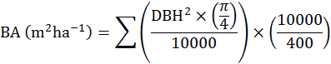

The percentage change in basal area for all species since 1964 for each subplot was calculated using the formula:



where represents the BA of a subplot in 1964 and represents the BA of a subplot in any of the subsequent survey years. Using these data, at each survey date we classified subplots into groups according to whether basal area had either remained stable or increased, or whether it had declined, defining a decline as a ≥25% reduction in BA since 1964. For some analyses subplots were also divided into five groups on the basis of the degree of BA decline, namely Stable or increasing, or 0-25%, 25-50%, 50-75% or 75-100% loss of BA compared to the 1964 value. These groups were used for plotting of maps



To examine temporal changes in plant biodiversity we calculated the species richness of subplots for both ground flora and for tree species. The quantitative Sørensen similarity index is commonly used to assess change in community composition but its use to assess changes in tree communities is problematic. This is because when calculated using stem density as a measure of abundance the index treats differently sized trees as equal, but when it is calculated using BA, differences in stem density are ignored. We therefore assessed tree community change using the Tanner index, which is calculated as the mean of quantitative Sørensen indices using basal area and stem density as defined by Chai et al. (2012) and using the equation:

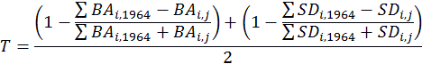

where and are the total BA and stem density for each tree species present in plot in 1964 and and are the same measurements in plot for year. Thus the Tanner index overcomes the limitations of the quantitative Sørensen index by accounting for both stem density and BA (Chai et al., 2012).



Where response variables represented a proportion, such as percentage cover or the Tanner index, we undertook the following transformation:



where is an individual variable value for plot for year and is the maximum value of the variable in the dataset. This transformation constrains model predictions between 1 and 0 as well as reducing the heteroschedasticity that is common when proportional data is incorrectly analysed (Warton and Hui, 2011). As recommended by Warton and Hui (2011), a small non-zero constant was added to all values so that logit transformed variables did not equal minus infinity.



Two approaches were adopted in our analysis of stand collapse. First, we divided the dataset into subplots that had collapsed (defined as ≥25% BA loss) at some point between 1964 and 2014 and those that had not, to examine the differences in changes in BA, stem density of saplings and trees >10 cm DBH, proportions of subplot BA represented by oak, and grass cover for the two groups in between 1964 and 2014. For stem density and grass cover we fitted linear mixed models with an interaction between year and collapse status (i.e. collapsed or not). Since stem density constitutes a count, poisson generalised linear mixed models were used to satisfy model assumptions. For analyses of BA and stem density time was considered as a continuous variable, while for analyses of changes of stem density of different size classes and grass cover it was considered as categorical.

In our second set of analyses, we examined variation over a gradient of change in the basal area. The relationships between the collapse gradient and species richness, ground flora Sørensen similarity, tree community Tanner similarity and community weighted trait values were each assessed using linear mixed models. For each of these models, linear, squared and cubed terms describing the shape of the relationship with the collapse gradient were tested to identify any potential non-linearity.

In both sets of analyses we used linear mixed models with subplot number as a random effect to account for repeated measures of the same subplots over time. Where the response variable consititued a count variable we used poisson generalised linear mixed models to satisfy model assumptions. All analyses were performed in R 3.1.2 (R Development Core Team, 2011) with mixed models produced using the lme4 package (Bates et al., 2014) and figures produced using ggplot2 (Wickham, 2009). Model selection followed an information theoretic approach, with models ranked by AICc to determine parsimony (Burnham and Anderson, 2002). Where only one model had a ΔAICc≤7 this was selected as the best model since this indicates little support for alternative models (Burnham et al., 2011). Where there was more than one model with a ΔAICc≤7, model averaging was undertaken with AICc weights used to calculate coefficients and associated standard error and P values using the MuMIn package (Barton, 2014). R2 values for mixed models were calculated following Nakagawa and Schielzeth (2013) and Johnson (2014) using the R package MuMIn.

In addition to formal statistical analyses we produced summaries of subplot recovery by dividing subplots into groups based on their initial decline in BA. Following this we determined the number of subplots of each group that had increased or further declined in BA following this initial decline and calculated the mean perecentage change in BA by 2014 for these groups. This allowed us to identify whether subplots tended to recover following a decline in BA and whether there was a threashold loss of BA below which recovery was unlikely.

To examine the spatial pattern of change in BA we produced maps showing the percentage BA decline of each subplot relative to 1964. To determine whether there was evidence of spatial autocorrelation in the severity of stand collapse Moran’s I correlation was calculated for pairwise comparisons of BA change between unenclosed and enclosed subplots separately using the R package ncf (Bjornstad, 2013). 1000 bootstrapped iterations were used to generate median values and 95% confidence intervals of Moran’s I values at lag distances of 20-1000 m, the minimum and maximum distance between subplots in the same transect. Where confidence intervals of the Moran’s I statistic overlapped zero, spatial autocorrelation was deemed to not be statistically significant.

**Results**

**Pattern of collapse**

Subplots showed large differences in their BA trajectories over time (Figure 1). During the first survey interval (1964 – 1984), basal area declined in 19 subplots but increased or remained stable in 27, whereas between the first and fourth survey intervals (1964 – 1996/9), BA declined in 43 subplots but increased or remained stable in 18. Overall, while 20 subplots recorded an increased or stable basal area over the entire survey period (1964-2014), 41 subplots recorded a decrease, 39 of which were associated with a decrease of ≥ 25%. The trajectory of BA decline differed between subplots, with many subplots displaying curvilinear responses. However, when all subplots were combined in the regression analysis, alinear model was the best fit overall (Figure 1).Particularly rapid changes in BA were observed between 1964 and 1984, when 19 subplots declined in BA with an overall mean (± SE) decline of 28.0% (± 6.4%); between 1984 and 1988, when 31 subplots declined in BA with an overall mean decline of 20% (± 3%); and between 1996/9 and 2014, when 13 subplots declined in BA with an overall mean decline of 32% (± 8%). 87% (14 out of 15) of subplots on the unenclosed transect demonstrated stand collapse (i.e. ≥ 25% BA decline) over the entire survey period, while on the enclosed transect 45% (22 out of 45) of subplots collapsed. All of the collapse observed in the unenclosed transect occurred during the period 1964–1996/9; thereafter, BA increased in 80% (12 of 15) of subplots on this transect.

Over the entire survey period the total decline in BA for all plots combined was 30.79 m2, with 61% of this attributable to losses of beech BA and 34% to loss of oak BA. The combined mortality of beech and oak trees >45 cm in DBH was responsible for the majority of these declines, constituting 61% and 30% of total BA losses respectively. For other size classes, only oak 25-45 cm DBH contributed more than 5% of the declines in total BA loss. In those subplots that collapsed (Figure 1a) mean (± SE) BA declined from 49.59 (± 2.35) m2 ha-1 in 1964 to 15.98 (± 2.94) m2 ha-1 in 2014, constituting a 67% loss. Those subplots in which BA remained stable or increased over time (Figure 1b) showed a mean increase in BA from 39.80 (± 3.06) m2 ha-1 to 47.61 (± 2.35) m2 ha-1 between 1964 and 2014. On average subplots that collapsed lost 0.53 (± 0.15) m2 ha-1 of BA per year (P<0.001, R2=0.25, Figure 1a) from 1964-2014, while stable subplots increased in BA at a rate of 0.14 (± 0.02) m2 ha-1 year-1 (P<0.001, Figure 1b).

Trajectories of decline in stem density also differed between subplots, although here the overall fitted response was curvilinear (Figure 2). Subplot stem density changes were best described by a regression model that included an interaction between survey year and whether subplots had collapsed at any point (Table S3). This model showed good fit (marginal R2=0.37); no other model had a ΔAICc ≤7 (Table S3). Parameter estimates of the model indicated that subplots that collapsed and those that did not showed no statistically significant difference in stem densities in 1964 (P=0.91), whereas both showed declines in stem density from 1964-2014. However, the model also suggested that collapsed plots showed a more rapid decline in stem density than stable plots (slope=-0.029, SE=0.003, P<0.001, Figure 2, Table S4).

Similarly, the most parsimonious model for describing density of trees >45 cm DBH within subplots included an interaction term between year and collapse status; no other model had had a ΔAICc≤7 (Table S5). Density of trees >45 cm DBH showed no statistically significant difference in 1964 between subplots that subsequently collapsed and those that did not (P=0.057), but by 2014 collapsed plots had significantly lower stem densities (Figure 3a, P<0.001). Mean (± SE) stem density of trees >45 cm DBH increased for stable plots from 68.75 (± 28.50) stems ha-1 in 1964 to 93.75 (± 29.50) in 2014 (P<0.001, Table S6). Over the same time period the mean density of trees >45 cm DBH decreased in collapsed subplots from 84.5 (± 29.25) in 1964 to 37.75 (±31.25) trees ha-1 (P<0.001, Figure 3a, Table S6). Trees with a DBH of 25-45 cm did not decrease in density for either stable (P=0.599) or collapsed plots (P=0.835). However, subplots that subsequently collapsed had a lower density of trees with a DBH of 25-45 cm in 1964 than did those that remained stable (P<0.001, Figure 3b, Table S8). Similarly, the density of trees with DBH of 15-25 cm was lower in subplots that subsequently collapsed in 1964 than those that remained stable (P<0.001, Figure 3c, Table S10), but there was no reduction in density by 2014 for collapsed or stable plots (P=0.426). Mean density of trees with a DBH of 10-15 cm declined between 1964 and 2014 for both collapsed and stable plots (P<0.001, Figure 3d, Table S12), but there were no significant differences between the two plot types in either 1964 (P=0.920) or 2014 (p=0.429).

Mean sapling density decreased for both collapsed and stable subplots between 1964 and 2014 (P<0.001, Figure S3, Table S29), with values in stable plots declining from 291 (± 28.75) to 70 (± 27.50) stems ha-1 and values in collapsed plots from 321.25 (± 29.5) to 69.25 (± 26.75) stems ha-1. However there was no statistically significant difference between collapsed and stable plots in 1964 (P=0.289) or 2014 (P=0.620). Subplots that collapsed had a higher density of beech seedlings (139.4 ± 1.2 seedlings ha-1) when compared to stable subplots (77.78 ± 1.1 seedlings ha-1, P<0.001). Similarly holly seedlings were more abundant in collapsed subplots (3451.52 ± 18.39 seedlings ha-1) than in stable subplots (1903.70 ± 8.42 seedlings ha-1, P<0.001). However, oak seedling densities were higher in stable than in collapsed subplots (122.22 ± 2.15 and 96.97 ± 2.44 seedlings ha-1 respectively, P<0.001).

Visual inspection of a map of the subplots (Figure 4) suggested that in 1964, none of the subplots were characterised by stand collapse. Collapse was first observed in 1984 in 19 subplots, and this then spread throughout both transects. By the 1996/9 surveys all but one of the unenclosed transect plots had suffered collapse (Figure 3d). Although subplots that were situated adjacent to collapsed plots appeared more likely to collapse, Moran’s I spatial correlograms indicated that spatial autocorrelation was not statistically significant at any pairwise distance between subplots that we examined (Figure S1).

**Consequences of dieback**

In plots where BA declined by ≥ 25% it tended not to recover (Table 5). While many subplots increased in BA following an initial loss, only in those that had initial declines of <25% did BA recover to values exhibited in 1964, with 43% of these subplots (3 of 7) achieving this degree of recovery by 2014 (Table 5). However, even for subplots that declined by < 25% of initial BA, the majority (4 of 7 subplots) failed to recover to BA values evident in 1964; in 2014, mean BA of these subplots was 11.8% (± 6.06) lower in 1964. While some subplots that showed initial losses of BA >25% also increased in BA following initial loss, 66% of subplots actually lost further BA by 2014.

Tree species richness showed a negative relationship with loss of BA (slope=-0.284 ± 0.108 SE, P=0.009, Table S13) but the most parsimonious models had very poor explanatory power (marginal R2=0.03-0.04, Table S14). Turnover in tree communities, as indicated by the Tanner Index, was strongly related to loss of BA (Figure 5). This relationship was best predicted by a model including both a linear and squared term for percentage basal area loss (R2=0.39, AICc=330.93), which provided a better fit than models of linear relationships (AICc= 406.00) or a null model (AICc=510.44, Table S15). The best model suggested a curvilinear response in tree community change with loss of BA, with losses of BA associated with large changes in community structure (Figure 5). Changes in tree community weighted Ellenberg values for light, nitrogen and moisture requirements showed little discernable trend with the decline in basal area, and in each case a null model was considered most parsimonious.

Changes in subplot grass cover were best described by a model with an interaction term between year and whether subplots collapsed during 1964-2014 (marginal R2=0.44, Table S17). In 1964, grass cover did not differ between subplots that subsequently collapsed and those that did not (P=0.64, Figure 6, Table S18), but by 1996 collapsed subplots showed significantly higher grass cover (Stable: 5.2% (± 3.5), Collapsed: 22.8% (± 8.8), P=0.009). This difference had increased by 2014 (Stable: 3.8% (± 2.7), Collapsed: 26.7% (± 9.4), P<0.001, Figure 6). Changes in grass cover in subplots were strongly related to loss of BA, showing a non-linear relationship (Figure 7). Model predictions suggested relatively little change in grass cover in subplots that increased in BA or showed losses <25%, while subplots that lost ≥25% of BA showed a rapid increase in grass cover with increasing loss of BA (Figure 7). In contrast to grass, bracken (*Pteridium spp.)* cover showed no significant relationship with loss of subplot BA with a null model the most well supported (Tables S30 and S31, Figure S5).

The highest ranked model explaining change in ground flora richness suggested a positive non-linear relationship with BA loss (Tables S21 and S22). Model averaged predictions suggested little difference in ground flora richness for subplots that showed <40% loss of BA, with an increase in species richness for subplots with greater declines in BA (Figure S2). In addition loss of basal area did not describe changes ground flora community composition well, with model selection suggesting that a null model was best supported.

Community weighted Ellenberg values for ground flora light requirements increased with increasing loss of BA (P < 0.001, Table S24), though the top ranked models showed relatively poor fit (marginal R2 = 0.10, Table S23). In addition a null intercept-only model was relatively highly ranked (ΔAICc=2.93) and thus cannot be completely rejected. Neither community weighted Ellenburg values for nitrogen nor moisture requirements showed any significant trend with the gradient of BA loss and all models showed poor descriptive power with marginal R2<0.04 (Tables S25 and S26).

**Discussion**

The results of our study provide a number of insights into the changes that occurred in a temperate forest ecosystem undergoing stand dieback over a period of several decades. This process of dieback was largely attributable to mortality of relatively large, mature trees, primarily of beech but also of oak. This was accompanied by a marked decline in density of juvenile trees (saplings) throughout the surveyed transects. Mortality was initiated at a relatively small number of discrete locations within the surveyed transects, but subsequently spread throughout much of the area. As the transects were surveyed at approximately decadal intervals, rather than annually, it was difficult to identify precisely when mortality events occurred, but the results indicate that significant dieback events occurred at several times during the survey period, and continued to occur during the past decade. After a period of around 50 years, some of the changes were very pronounced, particularly on the unenclosed transect, which was closed forest dominated by beech in 1964, but by 2014 was an open grassland with sporadic mature trees, mostly of oak. This provides evidence of a substantial transition, both in terms of forest structure and composition, which was also observed to a lesser degree in localised areas of the enclosed transect.

**Possible causes of die-back**

There has long been awareness that large beech trees have experienced high mortality rates in the New Forest in recent decades, although the precise causes remain uncertain (Newton, 2010; Tubbs, 2001). Manners and Edwards (1986) noted large numbers of dead beech occurring throughout the area, including within Denny Wood, in association with the widespread occurrence of the pathogenic fungi *Armillaria mellea* (agg.) and *Ganoderma* spp. However, the principal cause of large beech mortality in Denny wood and the wider New Forest was attributed to a major drought that occurred in the UK in 1976 (Manners and Edwards, 1986; Mountford and Peterken, 2003; Mountford et al., 1999). Similarly Peterken and Mountford (1996) described the impact of drought on beech in a single woodland, Lady Park Wood, monitored from 1945 onwards. Many mature beeches were killed immediately or severely damaged following the 1976 drought and drought-induced mortality continued for at least 15 years after this event. Additional mortality in Denny wood has previously been attributed to significant storms in 1987 and 1990, and in the case of smaller stemmed trees, to herbivory by deer ponies and grey squirrels (Mountford and Peterken, 2003; Mountford et al., 1999).

One of the striking features of the current results is that mortality of beech is continuing. For example, between 1996/9 and 2014, 13 subplots declined in BA with an overall mean decline of 32%. Rather than the legacy of the 1976 drought, this may be attributable to the ongoing effects of climate change in the UK. Since the 1980s, 10 of the 12 warmest years in the last 350 have been recorded, with winters becoming wetter and summers slightly drier (Jenkins et al., 2009). Mortality of beech has been observed throughout southern England (Power et al., 1995), which may be attributed to the combined effects of increased summer drought and increased winter waterlogging on poorly drained soils, which impedes root growth and thereby increases vulnerability to drought (Newton, 2011).

Recently the potential impacts of climate change and associated increases in the incidence of drought, pest attack and disease outbreaks have been highlighted by Allen et al. (2010) and Scholes et al. (2014) who gave 132 examples of forest mortality attributable to heat stress since 1970. These reviews indicated that the effects of drought can range from local to regional die-off, and have occurred on all forested continents and in diverse climates. However, many of the examples provided by Allen et al. (2010) and Scholes et al. (2014) are based on relatively short-term observations, with few studies analysing the process of forest dieback over multiple decades, as we have done in this study. Such long term datasets are vital for improving understanding of forest dynamics (Schimming et al., 2010), particularly following droughts which can cause mortality decades after the occurrence of drought stress (Bigler et al., 2007; Pedersen, 1998, 1999).

Beech dieback in southern England could be considered as part of a Europe-wide phenomenon. Particularly after the extreme drought of 2003 and the preceding wet autumn of 2002, widespread mortality of beech was observed in Central Europe, associated with *Phytophthora* diseases (Jung, 2009). Similar observations have been made elsewhere in Europe, including Sweden and Italy, as well as in the USA (Jung et al., 2006). While the presence of *Phytophthora* spp.in the New Forest has not been confirmed, it is possible that the observed colonisation of fungi such as *Armillaria* and *Ganoderma* is a secondary process following drought-induced *Phytophthora* attack, as suggested by Jung et al. (2006). The fact that soils in the site examined in this study are prone to waterlogging could also have been conducive to *Phytophthora* colonisation(Jung et al., 2006).However, the processes leading to drought-induced mortality of trees are poorly understood (Choat et al., 2012; McDowell et al., 2011; Sala et al., 2010) and as noted above, drought may be just one of several interacting factors responsible for the dieback observed here.

**Threshold responses and resilience**

Regardless of the cause of stand dieback noted in our study, it was associated with a number of threshold responses. Thresholds occur when the response of an ecological variable to a particular process is not linear, but changes abruptly (Huggett, 2005; Toms and Lesperance, 2003) and may be defined as points or zones at which relatively rapid change occurs from one ecological condition to another (Bennett and Radford, 2003). In the current study, the decline in both BA and stem density in individual subplots frequently displayed non-linear trajectories, although in the case of BA, the overall pattern of decline was best described by a linear model, reflecting variation in the timing and pattern of decline in individual subplots. Curvilinear responses to BA loss were observed in tree community change, as represented by the Tanner Index; in species richness of the ground flora; and in the percentage cover of grass. In addition, evidence suggested that the ability of subplots to recover following BA decline also demonstrated a threshold response; where BA declined by more than 25%, it tended not to recover. Critical values of BA for a change in ground flora species richness and grass cover were around 40% decline from initial values.

Ecological thresholds have attracted much research attention in recent yearsowing to the potentially serious consequences for both biodiversity and ecosystem function if thresholds are exceeded (Groffman et al., 2006). In particular there is a critical need for information regarding when an ecosystem is approaching a threshold, so that appropriate interventions can be identified. Identification and characterisation of thresholds has proved challenging in terrestrial ecosystems, because of the relatively low rate of change (Groffman et al., 2006), and the difficulties associated with obtaining appropriate field data (Huggett, 2005). Long-term monitoring data may have particular value in this context, as demonstrated here. The mechanisms underlying threshold responses are also often difficult to identify; Briske et al. (2006) suggests they may best be interpreted as a switch from the dominance of negative feedbacks that regulate ecosytems to positive feedbacks that may be associated with ecosystem degradation. In our study, positive feedbacks that may have been particularly influential include interactions between the physiological impacts of drought and colonisation by pathogenic fungi, although as suggested by (Simard et al., 2013), other elements of the system such as herbivores and ectomycorrhizal fungi may also have contributed to the responses observed. The ground flora thresholds observed here may be attributable to the effects of increasing light availability and declining root interference as stand dieback progressed. Further research would be required to confirm the influence of these mechanisms.

Much of the research on ecological thresholds has been presented in the context of regime shifts in ecosystems, and the associated concept of multiple stable states (Briske et al., 2006; Groffman et al., 2006). In a system with multiple states, disturbance may result in the system crossing a threshold from one state or regime to another, a process that potentially could be difficult to reverse (Folke et al., 2010b). Such regime shifts have been documented in a number of different ecosystem types (Scheffer et al., 2001), including forests (Folke et al., 2004, 2010a). Potentially, the transition recorded here from beech-dominated closed forest stands to open, park-like areas dominated by grass cover could be considered as an example of a regime shift, from which recovery has been limited to date. However, such an interpretation should be made with caution. Peterson (1984) and Petraitis (2013) have noted that a number of conditions must be met for the existence of multiple stable states to be confirmed, including demonstration that a site has the potential to be occupied by two or more distinct communities, the communities should be self-replicating, and the physical environment should not differ between the alternative states. In practice, these conditions are very rarely met in field situations (Peterson, 1984; Petraitis, 2013). The underlying theory of multiple stable states is also based on the assumption that the system is initially at equilibrium, and that the disturbance causing the regime shift is a ‘pulse’ (i.e. short-term) disturbance rather than a ‘press’ (i.e. continuous) disturbance. It is not clear that these conditions are fully met by the current example, suggesting that it might be better considered as providing evidence of “persistent alternative states” (Petraitis, 2013) rather than robust evidence of a regime shift.

Regardless of how it is defined, the collapse in beech stands observed here represents a significant challenge to forest management and conservation. The old-growth beech woodlands of the New Forest are of exceptional importance for biodiversity, providing habitat for highly diverse and internationally recognised communities of lichens, fungi and invertebrates (Newton, 2010). Given that the process of beech dieback observed in Denny Wood is also occurring in many other sites in the area (Tubbs, 2001), and is clearly ongoing, the potential impacts on biodiversity and the associated provision of ecosystem services (Boyd et al., 2013) could be very significant. In common with other examples of forest dieback currently being observed worldwide (Allen, 2009; Allen et al., 2010; Raffa et al., 2008; van Mantgem et al., 2009), the identification of appropriate management responses constitutes a major problem. Boyd et al. (2013) highlight the importance of increasing forest resilience to the interactions between climate change and pests and diseases, through improved management practices. In the case of the New Forest, this could most readily be addressed by protecting tree regeneration from the high herbivore pressure that currently prevails throughout the area, and limits recruitment of beech (Newton et al., 2013). Conversely, recognising the occurrence of ecological thresholds and the challenges associated with large-scale mortality, Messier et al. (2014) suggest that management might usefully focus on strengthening “adaptive capacity”, by allowing forest ecosystems to self-organize and to adapt to novel environmental conditions. In the current example, the implication of this approach would be to accept the ecosystem change that is occurring, despite the potential negative impacts on biodiversity and ecosystem service provision. Analysis of the long-term resilience of the New Forest as a socio-ecological system has highlighted its previous adaptive capacity, with long-term maintenance of the system over a period of centuries despite the occurrence of multiple external shocks (Newton, 2011). Whether the system has sufficient adaptive capacity to withstand the potential interactive effects of future climate change and spread of tree diseases represents a key unknown, with major implications for the development of future management strategies.

**Acknowledgements**

This research is funded by NERC via the Biodiversity & Ecosystem Service Sustainability (BESS) programme. Project ref. NE/K01322X/1.

**References**

Allen, C.D., 2009. Climate-induced forest dieback: An escalating global phenomenon? Unasylva 60, 43–49. doi:10.1029/2007EO470008

Allen, C.D., Macalady, A.K., Chenchouni, H., Bachelet, D., McDowell, N., Vennetier, M., Kitzberger, T., Rigling, A., Breshears, D.D., Hogg, E.H. (Ted), Gonzalez, P., Fensham, R., Zhang, Z., Castro, J., Demidova, N., Lim, J.H., Allard, G., Running, S.W., Semerci, A., Cobb, N., 2010. A global overview of drought and heat-induced tree mortality reveals emerging climate change risks for forests. For. Ecol. Manage. 259, 660–684. doi:10.1016/j.foreco.2009.09.001

Barton, K., 2014. MuMIn: Multi-model inference.

Bates, D., Maechler, M., Bolker, B., Walker, S., 2014. lme4: Linear mixed-effects models using Eigen and S4. ArXiv.

Bellassen, V., Luyssaert, S., 2014. Carbon sequestration: Managing forests in uncertain times. Nature 506, 153–155. doi:10.1038/506153a

Bennett, A., Radford, J., 2003. Know your ecological thresholds. Think. bush 2, 1–3.

Bestelmeyer, B.T., Ellison, A.M., Fraser, W.R., Gorman, K.B., Holbrook, S.J., Laney, C.M., Ohman, M.D., Peters, D.P.C., Pillsbury, F.C., Rassweiler, A., Schmitt, R.J., Sharma, S., 2011. Analysis of abrupt transitions in ecological systems. Ecosphere 2, art129. doi:10.1890/ES11-00216.1

Bigler, C., Gavin, D.G., Gunning, C., Veblen, T.T., 2007. Drought induces lagged tree mortality in a subalpine forest in the Rocky Mountains. Oikos 116, 1983–1994. doi:10.1111/j.2007.0030-1299.16034.x

Bjornstad, O.N., 2013. ncf: spatial nonparametric covariance functions. Version 1.1-5.

Boyd, I.L., Freer-Smith, P.H., Gilligan, C. a, Godfray, H.C.J., 2013. The consequence of tree pests and diseases for ecosystem services. Science 342, 1235773. doi:10.1126/science.1235773

Breshears, D.D., Cobb, N.S., Rich, P.M., Price, K.P., Allen, C.D., Balice, R.G., Romme, W.H., Kastens, J.H., Floyd, M.L., Belnap, J., Anderson, J.J., Myers, O.B., Meyer, C.W., 2005. Regional vegetation die-off in response to global-change-type drought. Proc. Natl. Acad. Sci. U. S. A. 102, 15144–8. doi:10.1073/pnas.0505734102

Briske, D.D., Fuhlendorf, S.D., Smeins, F.E., 2006. A Unified Framework for Assessment and Application of Ecological Thresholds. Rangel. Ecol. Manag. 59, 225–236. doi:10.2111/05-115R.1

Burnham, K.P., Anderson, D.R., 2002. Model selection and multimodel inference: a practical information-theoretic approach, Ecological Modelling. doi:10.1016/j.ecolmodel.2003.11.004

Burnham, K.P., Anderson, D.R., Huyvaert, K.P., 2011. AIC model selection and multimodel inference in behavioral ecology: some background, observations, and comparisons. Behav. Ecol. Sociobiol. 65, 23–35.

Cantarello, E., Newton, A.C., 2008. Identifying cost-effective indicators to assess the conservation status of forested habitats in Natura 2000 sites. For. Ecol. Manage. 256, 815–826. doi:10.1016/j.foreco.2008.05.031

Chai, S.-L., Healey, J.R., Tanner, E.V.J., 2012. Evaluation of forest recovery over time and space using permanent plots monitored over 30 years in a Jamaican montane rain forest. PLoS One 7, e48859. doi:10.1371/journal.pone.0048859

Choat, B., Jansen, S., Brodribb, T.J., Cochard, H., Delzon, S., Bhaskar, R., Bucci, S.J., Feild, T.S., Gleason, S.M., Hacke, U.G., Jacobsen, A.L., Lens, F., Maherali, H., Martínez-Vilalta, J., Mayr, S., Mencuccini, M., Mitchell, P.J., Nardini, A., Pittermann, J., Pratt, R.B., Sperry, J.S., Westoby, M., Wright, I.J., Zanne, A.E., 2012. Global convergence in the vulnerability of forests to drought. Nature 491, 752–5. doi:10.1038/nature11688

Ciesla, W.M., Donaubauer, E., 1994. Decline and Dieback of Trees and Forests: A Global Overview. Food & Agriculture Org.

Folke, C., Carpenter, S., Walker, B., Scheffer, M., Elmqvist, T., Gunderson, L., Holling, C.S., 2004. Regime Shifts , Resilience , in Ecosystem Management. Annu. Rev. Ecol. Evol. Syst. 35, 557–581. doi:10.2307/annurev.ecolsys.35.021103.30000021

Folke, C., Carpenter, S., Walker, B., Scheffer, M., Elmqvist, T., Gunderson, L., Holling, C.S., 2010a. Regime shifts, resilience, and biodiversity in ecosystem management, in: Gunderson, L., Allen, C., Holling, C. (Eds.), Foundations of Ecological Resilience. Island Press, Washington, pp. 119–150.

Folke, C., Carpenter, S.R., Walker, B., Scheffer, M., Chapin, T., Rockström, J., 2010b. Resilience thinking: Integrating resilience, adaptability and transformability. Ecol. Soc. 15. doi:10.1038/nnano.2011.191

Groffman, P.M., Baron, J.S., Blett, T., Gold, A.J., Goodman, I., Gunderson, L.H., Levinson, B.M., Palmer, M.A., Paerl, H.W., Peterson, G.D., Poff, N.L., Rejeski, D.W., Reynolds, J.F., Turner, M.G., Weathers, K.C., Wiens, J., 2006. Ecological Thresholds: The Key to Successful Environmental Management or an Important Concept with No Practical Application? Ecosystems 9, 1–13. doi:10.1007/s10021-003-0142-z

Hill, M.O., Preston, C.D., Roy, D.B., 2004. PLANTATT - attributes of British and Irish plants: status, size, life history, geography and habitats.

Hirota, M., Holmgren, M., Van Nes, E.H., Scheffer, M., 2011. Global resilience of tropical forest and savanna to critical transitions. Science (80-. ). 334, 232–235. doi:10.1126/science.1210657

Holling, C.S., 1978. Adaptive environmental assessment and management.

Huggett, A.J., 2005. The concept and utility of “ecological thresholds” in biodiversity conservation. Biol. Conserv. 124, 301–310. doi:10.1016/j.biocon.2005.01.037

Huntingford, C., Fisher, R.A., Mercado, L., Booth, B.B.B., Sitch, S., Harris, P.P., Cox, P.M., Jones, C.D., Betts, R.A., Malhi, Y., Harris, G.R., Collins, M., Moorcroft, P., 2008. Towards quantifying uncertainty in predictions of Amazon “dieback”. Philos. Trans. R. Soc. Lond. B. Biol. Sci. 363, 1857–64. doi:10.1098/rstb.2007.0028

Jenkins, G., Perry, M., Prior, J., Woodworth, P., 2009. UKCIP08: the climate of the United Kingdom and recent trends.

Johnson, P.C.D., 2014. Extension of Nakagawa & Schielzeth’s R 2 GLMM to random slopes models. Methods Ecol. Evol. n/a–n/a. doi:10.1111/2041-210X.12225

Jung, T., 2009. Beech decline in Central Europe driven by the interaction between Phytophthora infections and climatic extremes. For. Pathol. 39, 73–94. doi:10.1111/j.1439-0329.2008.00566.x

Jung, T., Hudler, G.W., Jensen-Tracey, S.L., Griffiths, H.M., Fleischmann, F., Osswald, W., 2006. Involvement of Phytophthora species in the decline of European beech in Europe and the USA. Mycologist 19, 159. doi:10.1017/S0269915X05004052

Keith, S.A., Newton, A.C., Morecroft, M.D., Bealey, C.E., Bullock, J.M., 2009. Taxonomic homogenization of woodland plant communities over 70 years. Proc. R. Soc. B Biol. Sci. 276, 3539–3544. doi:10.1098/rspb.2009.0938

Kirby, K., Smart, S., Black, H., Bunce, R., Corney, P., Smithers, R., 2005. Long term ecological change in British Woodland (1971-2001). Peterborough.

Kurz, W.A., Stinson, G., Rampley, G.J., Dymond, C.C., Neilson, E.T., 2008. Risk of natural disturbances makes future contribution of Canada’s forests to the global carbon cycle highly uncertain. Proc. Natl. Acad. Sci. U. S. A. 105, 1551–5. doi:10.1073/pnas.0708133105

Manners, J.G., Edwards, P.J., 1986. Death of old beech trees in the New Forest. Proc H F. Club Archaeol Soc 42, 155–156.

McDowell, N.G., Beerling, D.J., Breshears, D.D., Fisher, R. a, Raffa, K.F., Stitt, M., 2011. The interdependence of mechanisms underlying climate-driven vegetation mortality. Trends Ecol. Evol. 1–10. doi:10.1016/j.tree.2011.06.003

Mcintyre, P.J., Thorne, J.H., Dolanc, C.R., Flint, A.L., Flint, L.E., Kelly, M., Ackerly, D.D., 2014. Twentieth-century shifts in forest structure in California : Denser forests , smaller trees , and increased dominance of oaks 1–6. doi:10.1073/pnas.1410186112

Messier, C., Puettmann, K., Chazdon, R., Andersson, K., Angers, V., Brotons, L., Filotas, E., Tittler, R., Parrott, L., Levin, S., 2014. From management to stewardship: viewing forests as complex adaptive systems in an uncertain world. Conserv. Lett. 00, 1–10. doi:10.1111/conl.12156

Mountford, E.P., Peterken, G.F., 2003. Long-term change and implications for the management of wood-pastures: experience over 40 years from Denny Wood, New Forest. Forestry 76, 19–43. doi:10.1093/forestry/76.1.19

Mountford, E.P., Peterken, G.F., Edwards, P.J., Manners, J.G., 1999. Long-term change in growth, mortality and regeneration of trees in Denny Wood, an old-growth wood-pasture in the New Forest (UK). Perspect. Plant Ecol. Evol. Syst. 2, 223–272. doi:10.1078/1433-8319-00072

Mueller-Dombois, D., 1988. Stand-level dieback and ecosystem processes: A global perspective. GeoJournal 17, 162–164. doi:10.1007/BF02432916

Nakagawa, S., Schielzeth, H., 2013. A general and simple method for obtaining R 2 from generalized linear mixed-effects models. Methods Ecol. Evol. 4, 133–142. doi:10.1111/j.2041-210x.2012.00261.x

Newton, A.C., 2010. Biodiversity in the New Forest.

Newton, A.C., 2011. Social-ecological resilience and biodiversity conservation in a 900-yearold protected area. Ecol. Soc. 16. doi:http://dx.doi.org/10.5751/ES-04308-160413

Newton, A.C., Cantarello, E., 2015. Restoration of forest resilience: an achievable goal? New For. In review.

Newton, A.C., Cantarello, E., Tejedor, N., Myers, G., 2013. Dynamics and Conservation Management of a Wooded Landscape under High Herbivore Pressure. Int. J. Biodivers. 2013, 1–15. doi:10.1155/2013/273948

Pedersen, B.S., 1998. The role of stress in the mortality of midwestern oaks as indicated by growth prior to death. Ecology 79, 79–93. doi:10.1890/0012-9658(1998)079[0079:TROSIT]2.0.CO;2

Pedersen, B.S., 1999. The mortality of midwestern overstory oaks as a bioindicator of environmental stress. Ecol. Appl. 9, 1017–1027. doi:10.1890/1051-0761(1999)009[1017:TMOMOO]2.0.CO;2

Peng, C., Ma, Z., Lei, X., Zhu, Q., Chen, H., Wang, W., Liu, S., Li, W., Fang, X., Zhou, X., 2011. A drought-induced pervasive increase in tree mortality across Canada’s boreal forests. Nat. Clim. Chang. 1, 467–471. doi:10.1038/nclimate1293

Peterken, G., Mountford, E.P., 1996. Effects of drought on beech in Lady Park Wood, an unmanaged mixed deciduous woodland. Forestry 69, 125–136. doi:10.1093/forestry/69.2.125

Peterson, C.H., 1984. Does a rigorous criterion for environmental identity preclude the existence of multiple stable points? Am. Nat. 127–133.

Petraitis, P., 2013. Multiple Stable States in Natural Ecosystems. Oxford University Press.

Power, S.A., Ashmore, M.R., Ling, K.A., 1995. Recent trends in beech tree health in southern Britain and the influence of soil type. Water, Air, Soil Pollut. 85, 1293–1298. doi:10.1007/BF00477160

R Development Core Team, 2011. R: A Language and Environment for Statistical Computing. R Foundation for Statistical Computing, Vienna, Austria.

Raffa, K.F., Aukema, B.H., Bentz, B.J., Carroll, A.L., Hicke, J. a., Turner, M.G., Romme, W.H., 2008. Cross-scale Drivers of Natural Disturbances Prone to Anthropogenic Amplification: The Dynamics of Bark Beetle Eruptions. Bioscience 58, 501. doi:10.1641/B580607

Rietkerk, M., Dekker, S.C., de Ruiter, P.C., van de Koppel, J., 2004. Self-organized patchiness and catastrophic shifts in ecosystems. Science 305, 1926–1929. doi:10.1126/science.1101867

Sala, A., Piper, F., Hoch, G., 2010. Physiological mechanisms of drought-induced tree mortality are far from being resolved. New Phytol. 186, 274–281. doi:10.1111/j.1469-8137.2009.03167.x

Scheffer, M., Carpenter, S., Foley, J.A., Folke, C., Walker, B., 2001. Catastrophic shifts in ecosystems. Nature 413, 591–6. doi:10.1038/35098000

Scheffer, M., Carpenter, S.R., 2003. Catastrophic regime shifts in ecosystems: linking theory to observation. Trends Ecol. Evol. 18, 648–656. doi:http://dx.doi.org/10.1016/j.tree.2003.09.002

Scheffer, M., Carpenter, S.R., Lenton, T.M., Bascompte, J., Brock, W., Dakos, V., van de Koppel, J., van de Leemput, I. a., Levin, S. a., van Nes, E.H., Pascual, M., Vandermeer, J., 2012. Anticipating Critical Transitions. Science (80-. ). 338, 344–348. doi:10.1126/science.1225244

Schimming, C.-G., Augustin, S., Karez, R., 2010. The Scientific Potential of Environmental Monitoring, in: Müller, F., Baessler, C., Schubert, H., Klotz, S. (Eds.), Long-Term Ecological Research SE  - 4. Springer Netherlands, pp. 39–55. doi:10.1007/978-90-481-8782-9_4

Scholes, R., Settele, J., Betts, R., Bunn, S., Leadley, P., Nepstad, D., Overpeck, J., Taboada, M.G., 2014. Terrestrial and inland water systems, in: Field, C., Barros, V., Mach, K., Mastrandrea, M. (Eds.), Climate Change 2014: Impacts, Adaptation, and Vulnerability. Cambridge University Press, Cambridge, pp. 271–360.

Simard, S., Martin, K., Vyse, A., Larson, B., 2013. Meta-networks of fungi, fauna and flora as agents of complex adaptive systems, in: Messier, C., Puettmann, K., Coates, K. (Eds.), Managing Forests as Complex Adaptive Systems. Building Resilience to the Challenge of Global Change. Earthscan/Routledge, London and New York, pp. 133–164.

Staver, a C., Archibald, S., Levin, S. a, 2011. The global extent and determinants of savanna and forest as alternative biome states. Science 334, 230–2. doi:10.1126/science.1210465

Thrush, S.F., Hewitt, J.E., Dayton, P.K., Coco, G., Lohrer, A.M., Norkko, A., Norkko, J., Chiantore, M., 2009. Forecasting the limits of resilience: integrating empirical research with theory. Proc. Biol. Sci. 276, 3209–3217. doi:10.1098/rspb.2009.0661

Toms, J.D., Lesperance, M.L., 2003. PIECEWISE REGRESSION: A TOOL FOR IDENTIFYING ECOLOGICAL THRESHOLDS. Ecology 84, 2034–2041. doi:10.1890/02-0472

Tubbs, C.R., 2001. The New Forest: history, ecology and conservation. New Forest Ninth Centenary Trust.

Van Mantgem, P.J., Stephenson, N.L., Byrne, J.C., Daniels, L.D., Franklin, J.F., Fulé, P.Z., Harmon, M.E., Larson, A.J., Smith, J.M., Taylor, A.H., Veblen, T.T., 2009. Widespread increase of tree mortality rates in the western United States. Science 323, 521–524. doi:10.1126/science.1165000

Violle, C., Navas, M.-L., Vile, D., Kazakou, E., Fortunel, C., Hummel, I., Garnier, E., 2007. Let the concept of trait be functional! Oikos 116, 882–892. doi:10.1111/j.0030-1299.2007.15559.x

Warton, D.I., Hui, F.K.C., 2011. The arcsine is asinine: The analysis of proportions in ecology. Ecology 92, 3–10. doi:10.1890/10-0340.1

Wickham, H., 2009. ggplot2: elegant graphics for data analysis. Springer, New York.

**References**

1. Rietkerk, M. *et al.* 2004 *Science* 305, 1926-1929.

2. Bestelmeyer, B.T. *et al.* 2011 *Ecosphere* 2(12):129.

3. Millennium Ecosystem Assessment 2005 Island Press.

4. Scheffer, M. *et al.* 2009 *Nature* 461, 53-59.

5. Scheffer, M. *et al.* 2012 *Science* 338, 344-348

6. Biggs, R. *et al.* 2009 *PNAS* 106, 826-831

7. Carpenter, S.R. & Brock, W.A. 2006 *Ecology Letters* 9, 311-318.

8. Carpenter, S.R. *et al.* 2011 *Science* 332, 1079-1082.

9. Veraart, A.J. *et al.* 2012 *Nature* 481, 357-359.

10. Dai, L. et al. 2012 *Science* 336, 1175-1177.

11. Hastings, A. & Wysham, D.B. 2010 *Ecology Letters* 13, 464-472.

12. Thrush, S.F. *et al.* 2009 *Proc. R. Soc. B* 276, 3209-3217.

13.

14. UK National Ecosystem Assessment 2011 UNEP-WCMC, Cambridge.

15. Keith, S.A. *et al.* 2009 *Proc. Roy. Soc.* 276, 3539-3544.

16. Allen, C.D. 2009 *Unasylva* 231/232 60(1-2), 43-49.

**17. Breshears, D.D. *et al.* 2005** PNAS 102(42), 15144–15148.

**18. Huntingford, C. *et al.*** 2008 Phil. Trans. Roy. Soc. Ser. B 363(1498), 1857–1864.

**19. Kurz, W.A. *et al.* 2008 *PNAS*** 105, 1551–1555.

**20. Raffa, K.F. *et al*.** 2008. Bioscience 58(6), 501–517.

**21. van Mantgem, P.J. *et al.* 2009** Science 323, 521–524.

22. Newton, A.C. 2010 *Biodiversity in the New Forest*. Pisces, Hampshire.

23. Newton, A.C. 2011 *Ecology and Society* 16(4), 13.

24. Mountford, E.P. *et al.* 1999 *Persp. in Plant Ecol., Evol. & Syst.* 2(2), 223-272.

25. Mountford, E.P. & Peterken, G.F. 2003 *Forestry* 76(1), 19-43.

26. Newton, A.C. *et al.* 2012 *Biol. Cons*. In review.

27. Mladenoff, D.J. 2004. *Ecol. Modelling* 180, 7-19.

28. Scheller, R.M. *et al.* 2007. *Ecol*. *Modelling* 201, 409-419.

29. Birch, J. *et al.* 2010 *PNAS* 107(50), 21925-21930.

30. Carpenter, D. *et al.* 2012 *Biodiv*. *Conserv*. 21, 3385–3410.

31. Scheller, R.M. *et al.* 2011. *Ecol*. *Modelling* 222, 144-153.

32. Newton, A.C. 2007. *Forest ecology and conservation.* Oxford UP.

33. Peterken, G.F. *et al*. 1996 Forestry Commission.

34. Ray, D. 2001 *Ecological Site Classification*. Forestry Commission.

35. Newton, A.C. & Haigh, J. 1998 *New Phytol.* 138, 619-627.

36. de Val, G. *et al.* 2006 *Land. and Urban Planning* 77, 393–407.

37. Soliva, R. & Hunziker, M. 2009 *Biodiv. & Cons.* 18, 2483–2507.

38 Fukami, T. & Wardle, D.A. 2005 Proc. Roy. Soc. 272, 2105-2115.

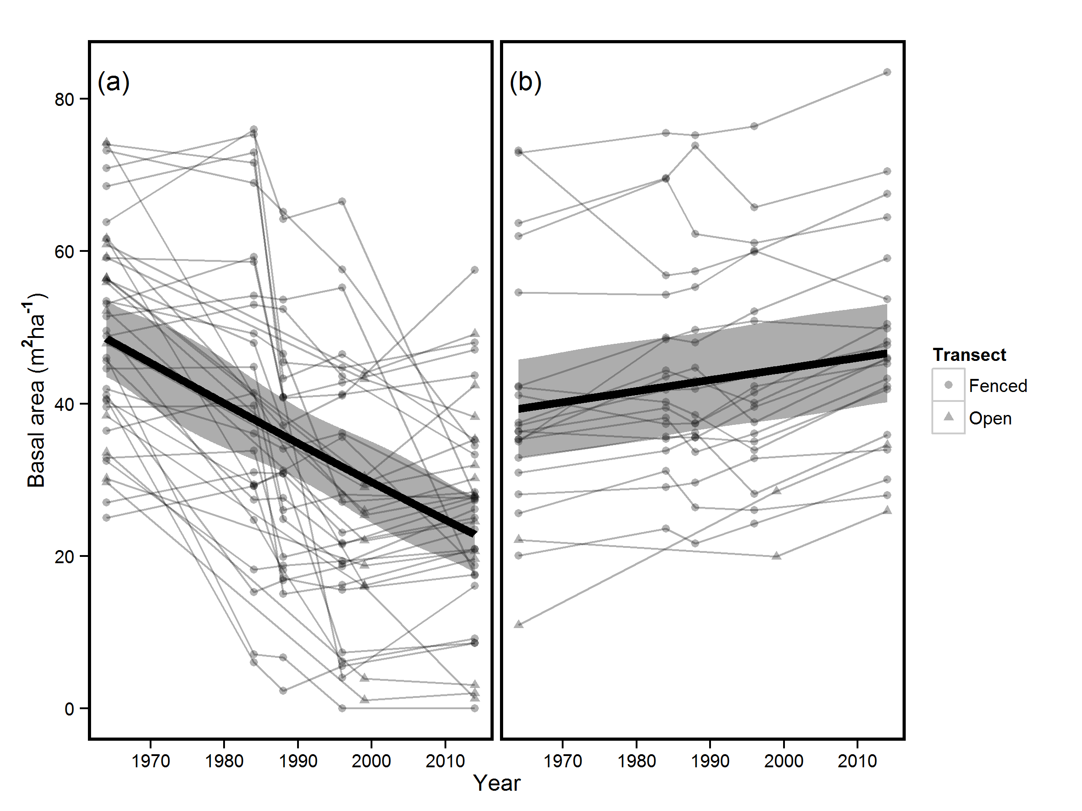

Figure 1 – Changes in plot BA over the period 1964-2014 for plots that (a) collapsed at some point during this period (≥25% decline in BA) and (b) those that were stable or increased in BA. Circles and triangles represent plots in the fenced and unfenced parts of the woodland respectively. Thin lines represent dynamics of individual plots, with points showing the survey times. Thick lines represent predictions made using model averaged coefficients in (a) which had marginal R2 values of 0.25-0.26 and the coefficients of the best model in (b) which had a marginal R2 of 0.02.Grey bands represent the confidence intervals for the model coefficients.

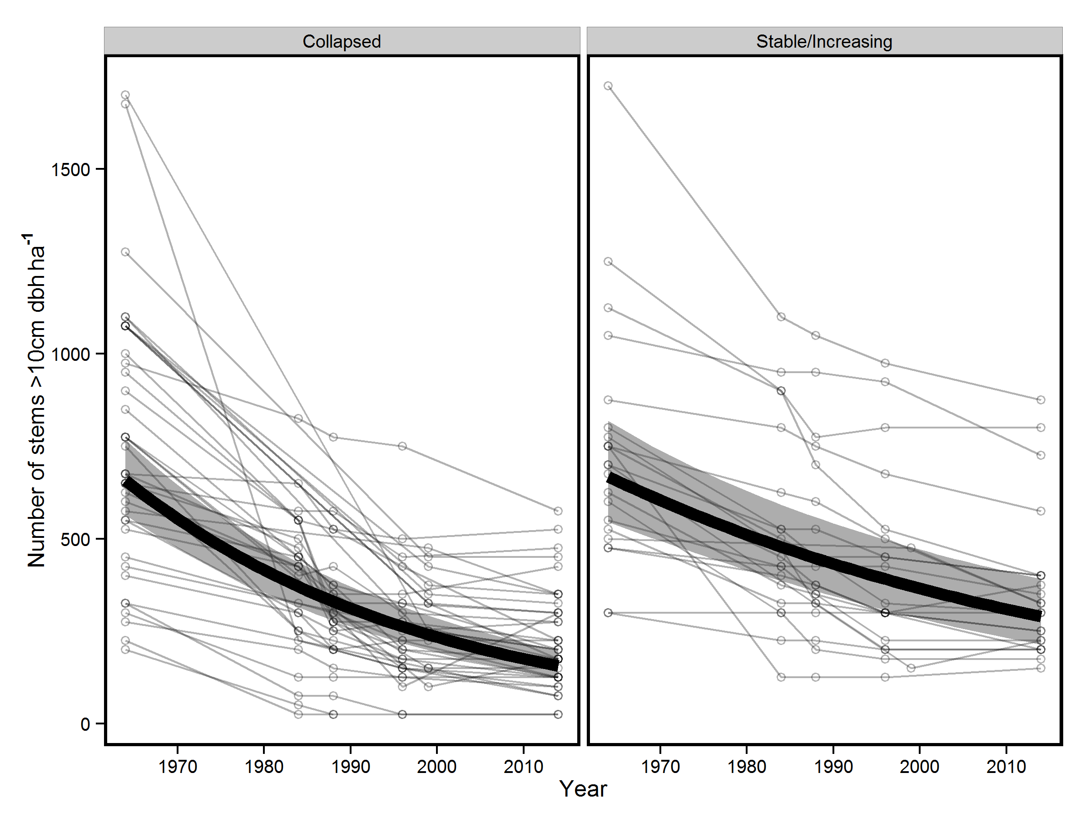

Figure 2 – Changes in subplot stem density over the period 1964-2014 for plots that collapsed at some point during this period (≥25% decline in BA) and those that were stable or increased in BA. Thin lines represent dynamics of individual plots, with points showing the survey times. Thick lines represent predictions made using the most parsimonious mixed model (n=275, R2=0.37, Tables S3 and S4), and grey bands represent the confidence intervals for the model coefficients. Need to label (a) and (b) on figure and refer to this in caption

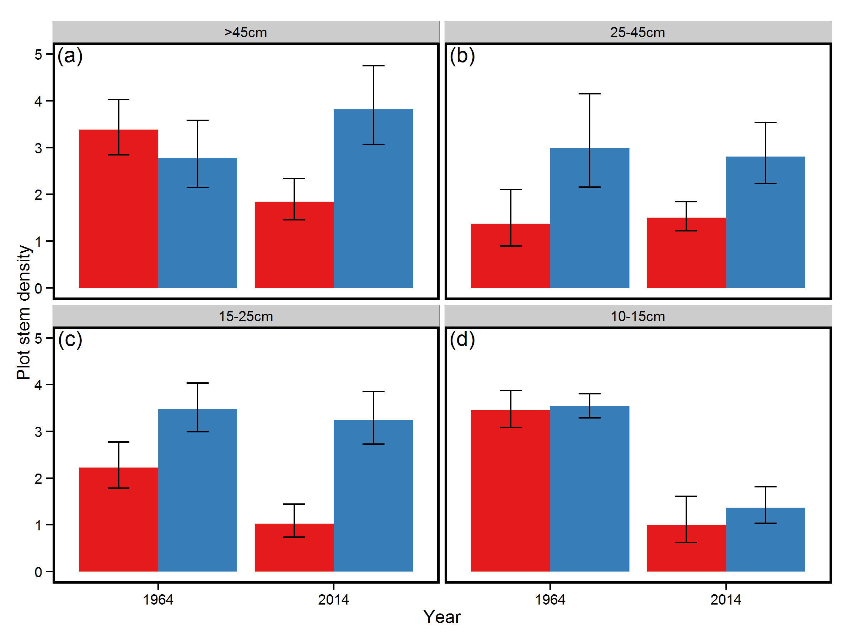

Figure 3 – Differences in stem density for trees (a) >45cm DBH, (b) 25-45cm DBH, (c) 15-25cm DBH and (d) 10-15cm DBH in subplots that collapsed at some point from 1964-2014 (red) and those that remained stable (blue). Data are presented for the years 1964 and 2014. Bars represent model averaged coefficients of generalised mixed models and error bars 95% confidence intervals of these coefficients. I think we can delete this figure, there is plenty of detail in the text.

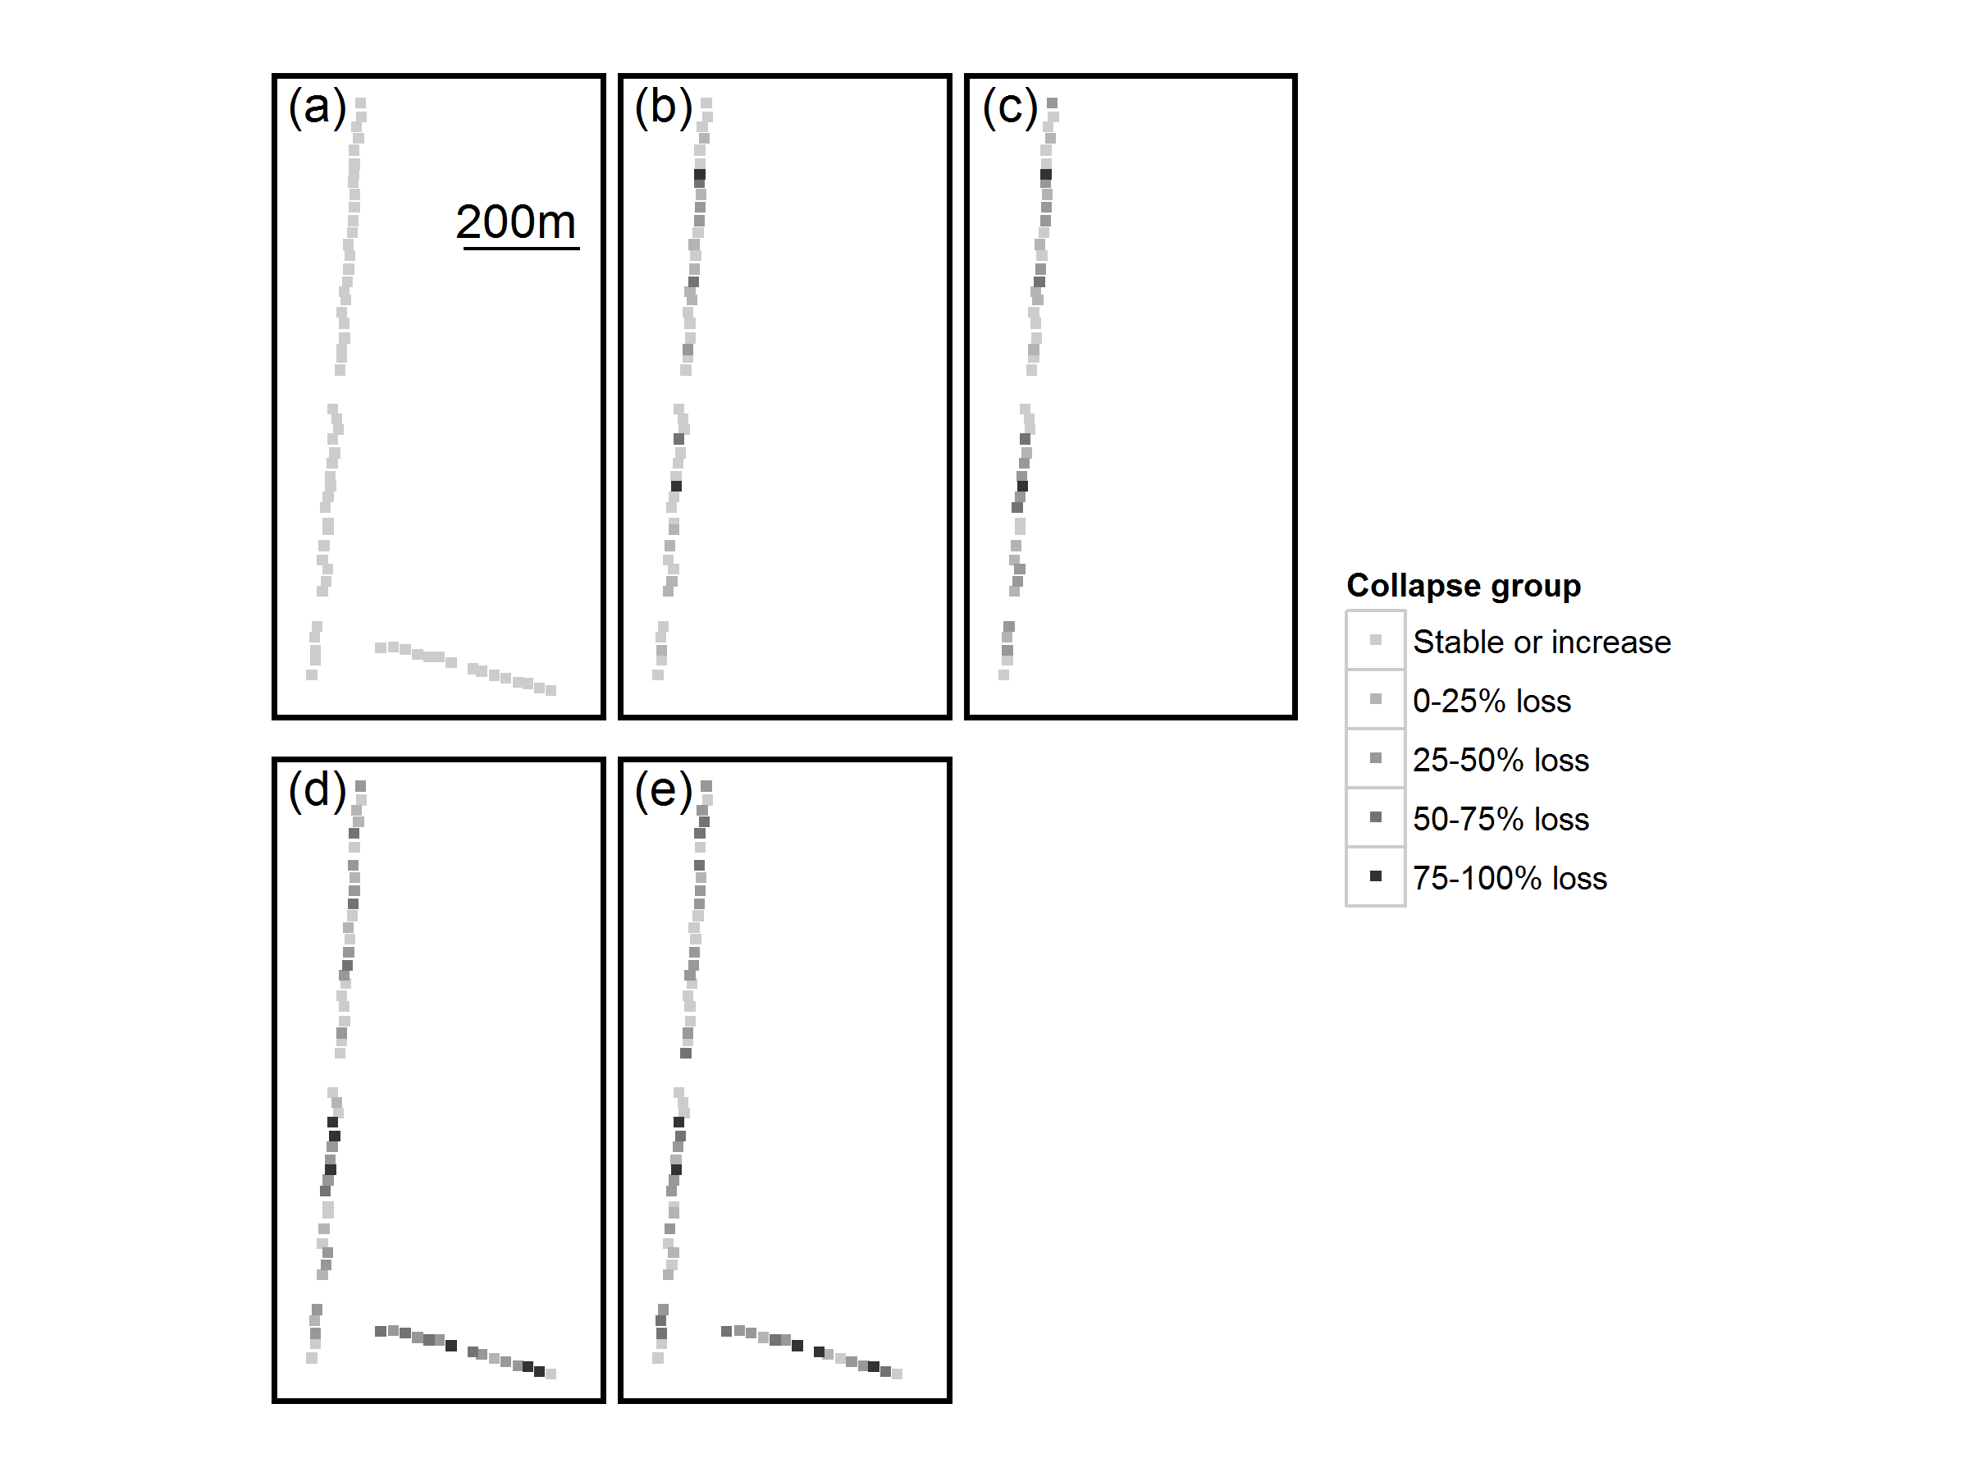

Figure 4 – Spatial distribution of plots at differing stages of collapse for the years (a) 1964, (b) 1984, (c) 1988, (d) 1996/9 and (e) 2014. Each square represents a 20x20m plot and the figure is to scale – see plot (a). Note that in 1984 and 1988 the shorter, unenclosed transect was not surveyed and hence is not shown for these years. The colour scale represents the changes in plot basal area and includes those that increased in basal area, and those that lost 0-25%, 25-50%, 50-75% and 75-100% of basal area. I still think that this figure will need to be bigger for the subplots to be more visible

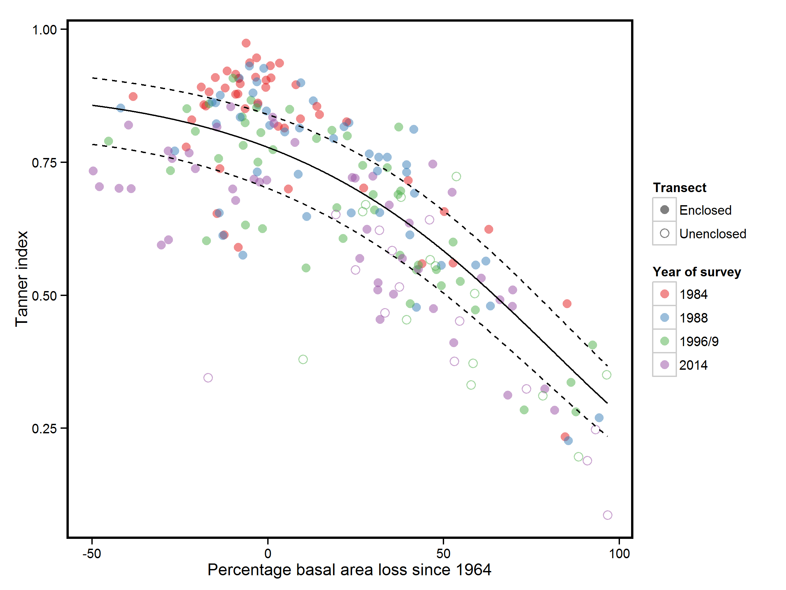

Figure 5 – Relationship between percentage loss in plot basal area and species composition changes as measured using the Tanner index (n=210). Where Tanner index values are closer to 1 species composition is more similar to the same plot in 1964. Circles represent individual plots surveyed in 1984 (red), 1988 (blue), 1996/9 (green), or 2014 (purple). Closed circles represent plots on the enclosed transect and open circles those on the unenclosed transect. The line represents the most parsimonious model fit (R2=0.47), with dashed lines representing the 95% confidence intervals around the coefficient. For more details of model see Tables S13 and S14. Use of small or capital I for Tanner Index is not consistent throughout the manuscript, please check this

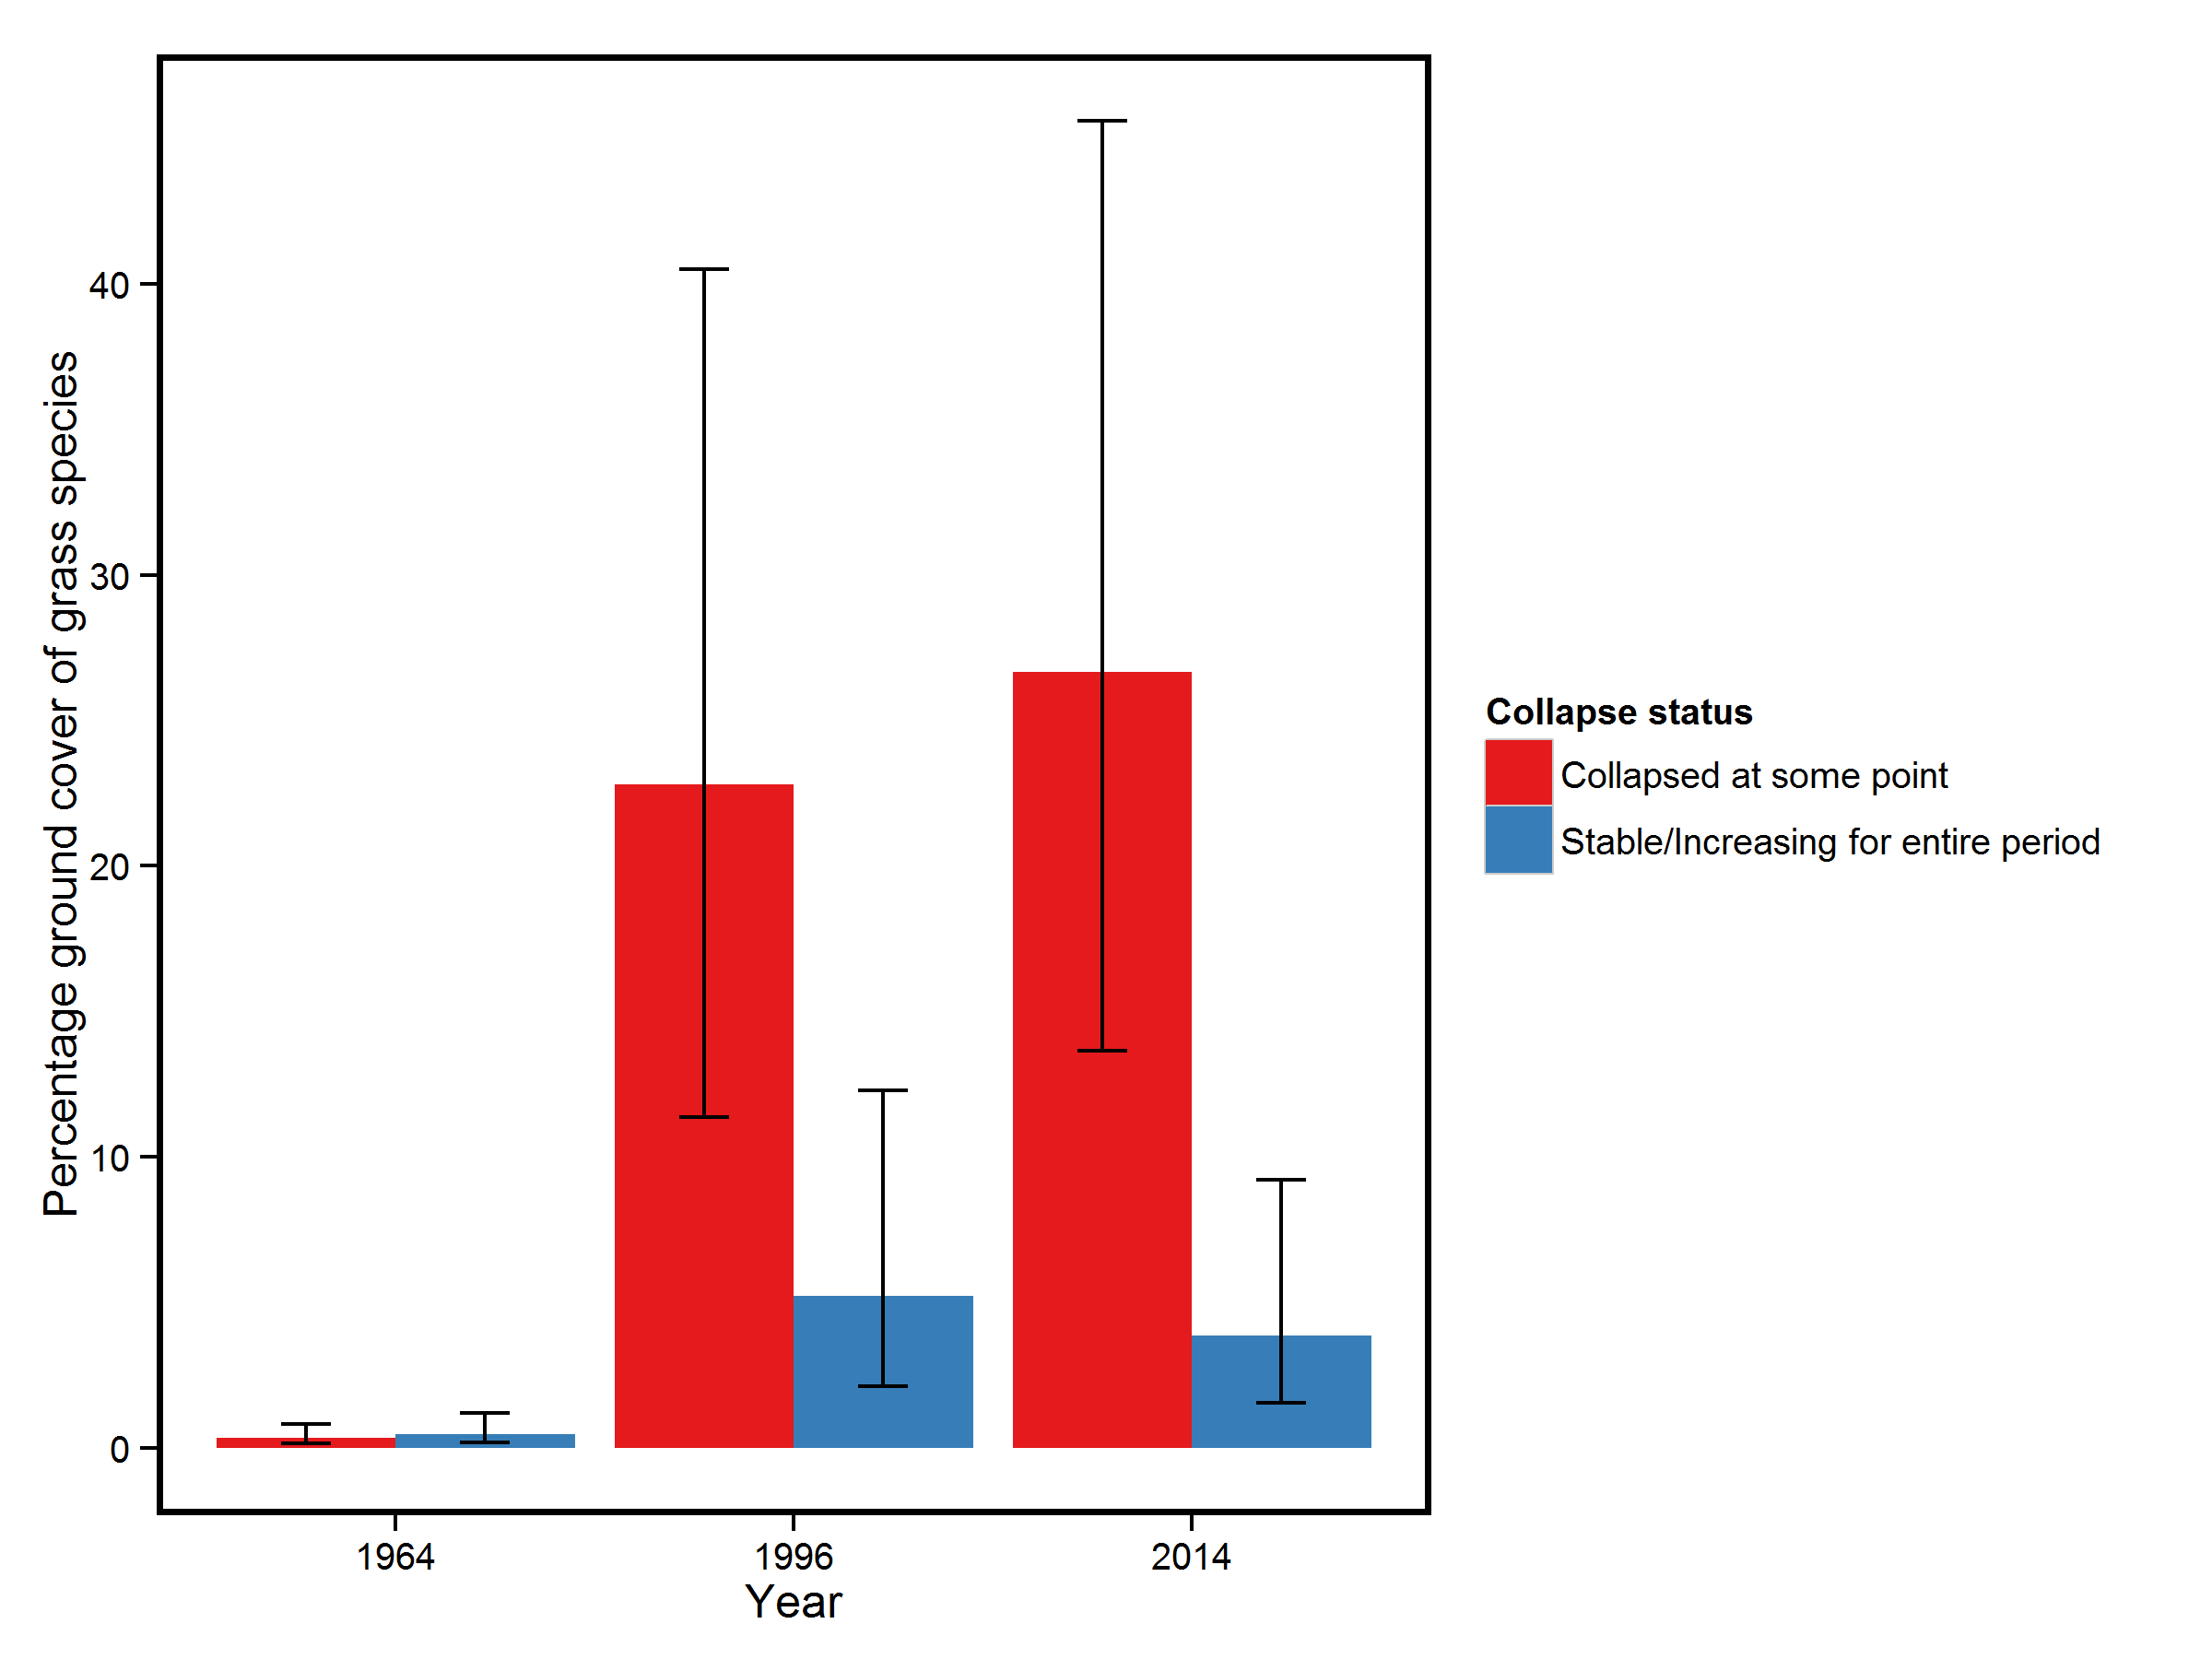

Figure 6 – Changes in mean subplot percentage grass cover for the Inclosed area of Denny wood, for subplots that collapsed at some point from 1964-2014 (red bars) and those that were stable during this period (blue bars). Error bars represent 95% confidence intervals of the most parsimonious model explaining changes in grass cover (marginal R2=0.44). There was no difference amongst subplot grass cover in 1964 but by 1996 collapsed subplots had significantly greater grass cover than stable subplots (P=0.009) and this difference increased by 2014 (P<0.001). I think this could probably be deleted as it is all in the text, or make sure it is all in the text.

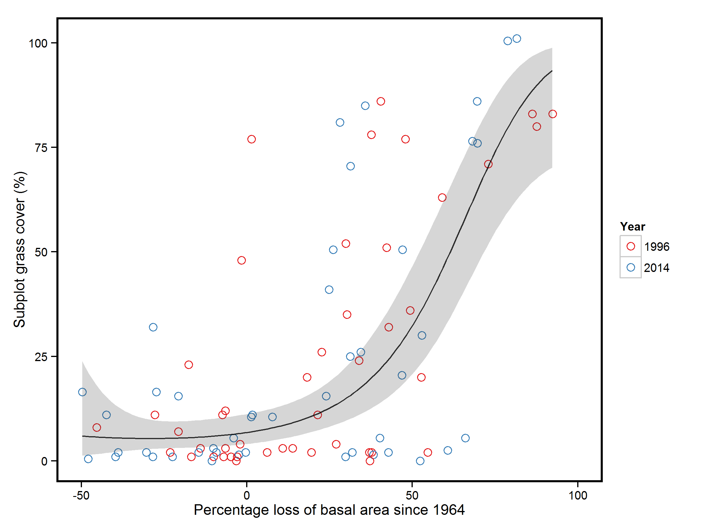

Figure 7 – Relationship between percentage loss in subplot basal area and percentage grass cover. Circles represent individual subplots on the enclosed transect surveyed in 1996 (red) or 2014 (blue). The line represents prediction using model averaged coefficients and grey shading the 95% confidence intervals of the coefficients (marginal R2=0.39). Only subplots from the enclosed transect are included in this figure as data on ground cover was missing for the unenclosed transect for 1964.

What is the difference between Table 1 and Table 2? Is one tree species and the other ground flora? If so you need to make this clear in the table caption. There is nothing in the caption to Table 1 to say it just relates to tree species. Also, I don’t think we need both in the main text. Maybe just keep the ground flora and put the other in the SI

Table 1 – Characteristics of subplots summarised by different categories of collapse per year. Collapse groups are those that had stable or increasing basal area, those that showed a 0-25% decline in basal area, a 25-50% decline in basal area, a 50-75% decline in basal area and a 75-100% decline in basal area. Summaries represent mean values of each metric per collapse category and numbers in brackets are one standard error of the mean. In the column detailing the number of subplots numbers in brackets indicate the number of subplots in the fenced and unfenced parts of the woodland.

|  |  |  |  |  |  |  |  |  |  |  |
| --- | --- | --- | --- | --- | --- | --- | --- | --- | --- | --- |
| **Year** | **Group** | **Number of subplots** | **Proportion of subplots** | **Basal area** | **Percentage basal area change** | **Stem density** | **Tanner index** | **Species richness** | **Ellenburg light indicator** | **Ellenburg nitrogen indicator** |
| 1984 | Stable or increase | 27 (27,0) | 0.59 | 47.91 (3.06) | 11.66 (1.57) | 19.26 (1.74) | 0.85 (0.02) | 2.89 (0.16) | 2.78 (0.21) | 1.57 (0.05) |
| 1984 | 25-0% | 11 (11,0) | 0.24 | 51.01 (3.85) | -7.06 (1.92) | 19 (3.18) | 0.85 (0.02) | 3 (0.13) | 2.56 (0.25) | 1.62 (0.06) |
| 1984 | 50-25% | 3 (3,0) | 0.07 | 25.01 (3.43) | -36.98 (5.03) | 12 (5.03) | 0.66 (0.05) | 2.33 (0.33) | 1.74 (0.64) | 1.83 (0.17) |
| 1984 | 75-50% | 3 (3,0) | 0.07 | 23.04 (4.09) | -55.23 (3.87) | 11.67 (3.76) | 0.61 (0.03) | 2.33 (0.33) | 3.05 (1.11) | 1.51 (0.28) |
| 1984 | 100-75% | 2 (2,0) | 0.04 | 7.38 (1.35) | -83.07 (2.06) | 12 (10) | 0.4 (0.09) | 2 (0) | 1.92 (0.55) | 2 (0) |
| 1988 | Stable or increase | 17 (17,0) | 0.37 | 46.28 (3.66) | 10.97 (2.57) | 18.88 (2.15) | 0.83 (0.02) | 3.12 (0.19) | 3.01 (0.23) | 1.51 (0.06) |
| 1988 | 25-0% | 13 (13,0) | 0.28 | 42.92 (3.33) | -14.13 (2.16) | 15.62 (2.73) | 0.77 (0.03) | 2.77 (0.17) | 2.3 (0.21) | 1.69 (0.05) |
| 1988 | 50-25% | 11 (11,0) | 0.24 | 30.53 (3.15) | -37.93 (1.89) | 12.09 (2.36) | 0.69 (0.03) | 2.18 (0.23) | 2.6 (0.51) | 1.61 (0.13) |
| 1988 | 75-50% | 3 (3,0) | 0.07 | 16.66 (0.92) | -61.49 (1.25) | 9.67 (0.88) | 0.53 (0.03) | 2.33 (0.33) | 1.98 (0.87) | 1.77 (0.23) |
| 1988 | 100-75% | 2 (2,0) | 0.04 | 4.8 (2.48) | -89.22 (5.06) | 6.5 (4.5) | 0.29 (0.02) | 2 (0) | 2 (0.83) | 2 (0) |
| 1996/9 | Stable or increase | 18 (17,1) | 0.39 | 46.89 (3.44) | 25.66 (8.18) | 16.84 (1.91) | 0.77 (0.02) | 3 (0.15) | 2.84 (0.19) | 1.55 (0.05) |
| 1996/9 | 25-0% | 9 (8,1) | 0.2 | 44.87 (4.5) | -13.72 (1.92) | 14 (3.25) | 0.7 (0.05) | 3 (0.15) | 3.13 (0.34) | 1.48 (0.08) |
| 1996/9 | 50-25% | 19 (13,6) | 0.24 | 30.7 (2.51) | -38.42 (1.64) | 11.47 (1.64) | 0.62 (0.02) | 2.12 (0.17) | 2.55 (0.39) | 1.64 (0.1) |
| 1996/9 | 75-50% | 8 (4,4) | 0.07 | 20.87 (1.54) | -56.32 (1.08) | 9.57 (2.08) | 0.51 (0.05) | 2.71 (0.29) | 3.47 (0.65) | 1.41 (0.16) |
| 1996/9 | 100-75% | 6 (3,3) | 0.11 | 5.64 (1.71) | -88.42 (2.52) | 7.88 (1.97) | 0.28 (0.03) | 2.12 (0.4) | 2.5 (0.4) | 1.83 (0.11) |
| 2014 | Stable or increase | 20 (18,2) | 0.35 | 49.08 (3.25) | 37.77 (9.92) | 14.24 (1.54) | 0.7 (0.02) | 3 (0.14) | 2.69 (0.2) | 1.59 (0.05) |
| 2014 | 25-0% | 7 (5,2) | 0.13 | 46.09 (4.64) | -17.09 (3.05) | 15 (3.11) | 0.68 (0.04) | 2.75 (0.25) | 2.94 (0.47) | 1.54 (0.12) |
| 2014 | 50-25% | 18 (13,5) | 0.27 | 28.58 (1.89) | -36.77 (1.52) | 8.88 (1.1) | 0.58 (0.02) | 2.31 (0.3) | 2.32 (0.41) | 1.69 (0.1) |
| 2014 | 75-50% | 10 (7,3) | 0.15 | 24.68 (2.4) | -61.37 (2.83) | 10.11 (2.26) | 0.47 (0.04) | 2.89 (0.26) | 3.69 (0.39) | 1.35 (0.09) |
| 2014 | 100-75% | 5 (3,2) | 0.1 | 5.46 (1.51) | -86.26 (3.42) | 5 (1.06) | 0.23 (0.03) | 1.5 (0.22) | 2.06 (0.39) | 2.04 (0.04) |

|  |  |  |  |  |  |  |  |  |  |  |
| --- | --- | --- | --- | --- | --- | --- | --- | --- | --- | --- |
| **Year** | **Group** | **Number of subplots** | **Proportion of subplots surveyed** | **BA** | **Percentage change in BA** | **Percentage cover of grass** | **Sorensen similarity** | **Species richness** | **Ellenburg Light indicator** | **Ellenburg nitrogen indicator** |
| 1996 | Stable or increase | 17 | 0.38 | 44.66 (3.37) | 12.77 (2.8) | 8.06 (2.89) | 0.21 (0.05) | 6.94 (0.77) | 5.99 (0.39) | 3.41 (0.24) |
| 1996 | 25-0% | 8 | 0.18 | 48.36 (5.17) | -14.23 (2.69) | 18 (9.02) | 0.07 (0.03) | 6.25 (1.01) | 6.51 (0.14) | 3.06 (0.12) |
| 1996 | 50-25% | 13 | 0.29 | 31.21 (3.08) | -37.95 (1.86) | 36.85 (8.48) | 0.12 (0.05) | 8.58 (0.79) | 6.17 (0.52) | 3.09 (0.27) |
| 1996 | 75-50% | 4 | 0.09 | 15.93 (3.07) | -59.82 (4.56) | 39 (16.66) | 0.02 (0.02) | 9.25 (1.93) | 6.59 (0.1) | 3.62 (0.09) |
| 1996 | 100-75% | 3 | 0.07 | 5.26 (0.63) | -88.74 (1.86) | 82 (1) | 0.03 (0.02) | 16 (1.15) | 6.78 (0.01) | 3.73 (0.03) |
| 2014 | Stable or increase | 18 | 0.4 | 49.31 (3.26) | 23.74 (3.73) | 6.39 (2.03) | 0.12 (0.03) | 8.12 (1.14) | 5.92 (0.37) | 3.19 (0.23) |
| 2014 | 25-0% | 5 | 0.11 | 46.03 (7.31) | -11.89 (5.23) | 17.7 (5.9) | 0.04 (0.02) | 7.2 (1.62) | 6.55 (0.13) | 3.32 (0.19) |
| 2014 | 50-25% | 13 | 0.29 | 28.58 (2.36) | -35.67 (1.91) | 32.38 (8.77) | 0.09 (0.05) | 8 (1.01) | 6.62 (0.09) | 3.25 (0.15) |
| 2014 | 75-50% | 7 | 0.16 | 22.65 (3.81) | -62.76 (2.86) | 39.5 (14.67) | 0.08 (0.03) | 9.57 (2.09) | 6.44 (0.12) | 3.7 (0.38) |
| 2014 | 100-75% | 2 | 0.04 | 8.88 (0.28) | -80.15 (1.37) | 99.75 (0.25) | 0.01 (0) | 16 (2) | 6.85 (0) | 3.16 (0.19) |

Table 2 – Characteristics of ground flora in subplots summarised by different categories of collapse per year. Collapse groups are those that had stable or increasing basal area, those that showed a 0-25% decline in basal area, a 25-50% decline in basal area, a 50-75% decline in basal area and a 75-100% decline in basal area. Summaries represent mean values of each metric per collapse category and numbers in brackets are one standard error of the mean. Subplots summarised are only those from the fenced part of the woodland.

Table 5 – Change in subplot BA post-collapse for different severities of collapse. Collapse group represents the initial percentage loss in BA from the subplot. Subplots are identified as to whether they have shown any increase in BA after their initial loss. Numbers in brackets represent one standard error of the mean. Note that only subplots that declined by between 0 and 25% recovered to their pre-collapse BA. Not needed in main manuscript, put in SI

|  |  |  |  |
| --- | --- | --- | --- |
| Collapse group | Increased in BA since collapse | Mean percentage BA change since 1964 | Number of subplots |
| 0-25% | No | -11.79 (6.06) | 4 |
| 0-25% | Yes | 0.92 (5.14) | 3 |
| 25-50% | No | -36.63 (1.79) | 10 |
| 25-50% | Yes | -24.68 (4.10) | 8 |
| 50-75% | No | -58.33 (3.53) | 9 |
| 50-75% | Yes | -44.93 (2.14) | 2 |
| 75-100% | No | -92.45 (3.14) | 5 |
| 75-100% | Yes | -74.22 (4.56) | 2 |